IHE Change Proposal

Tracking information:
IHE Domain | Patient Care Coordination
Change Proposal ID: | CP-PCC-xxx
Change Proposal Status: | Submitted
Date of last update: | 2016-12-06
Person assigned: | (assigned by Domain Technical Committee)

Change Proposal Summary information:
Healthy Weight Care Plan Section LOINC Code
Submitter’s Name(s) and e-mail address(es): | Steve Moore, smoore@wustl.edu
Submission Date: | 2016-12-06
Integration Profile(s) affected: | None
Actor(s) affected: | None
IHE Technical Framework or Supplement modified: | PCC CDA Content Modules Supplement, 2016-11-11
Volume(s) and Section(s) affected: | 2: 6.3.2.5 (Spouse)
Rationale for Change:
Issue 1:
PCC TF 2: 6.3.2.4 describes Patient Contacts 1.3.6.1.4.1.19376.1.5.3.1.2.4
There are these requirements listed:

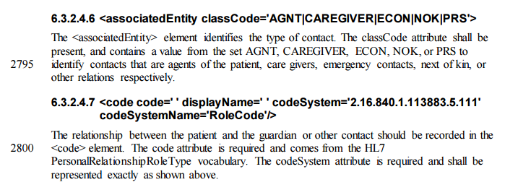
Now we look in the Supplement for CDA Content. In 6.3.2.5 Spouse 1.3.6.1.4.1.19376.1.5.3.1.2.4.1, we read that spouse inherits from Patient Contacts. Section 6.3.2.5.5 is quoted below and seems to contradict the text above in section 6.3.2.4.7 pertaining to the allowed values for code and codeSystem.

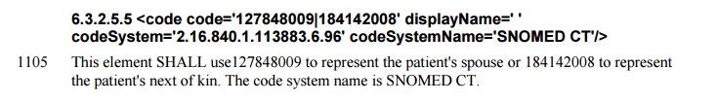
Issue 2:
The second issue looks like an issue of consistency in the CDA Content Modules Supplement itself. Section 6.3.2.5.4 says that the classCode attribute of <associatedEntity> shall be ‘PRS’ while the example in 6.3.2.5.6 uses the value ‘NOK’
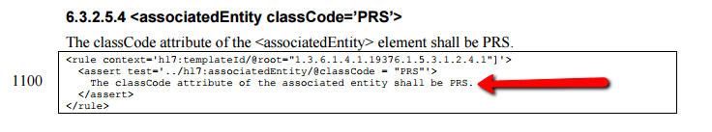
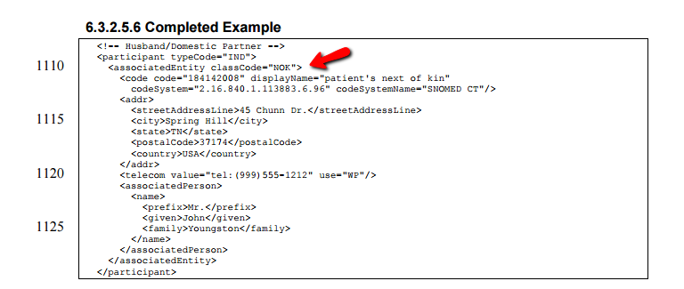

- Does 6.3.2.4.7 describe a fixed/closed set of codes? Or, can the codes and coding system be extended as suggested in 6.3.2.5.5.
- Is the classCode value (NOK) in the example wrong? Is it contained to always be "PRS"?
2a) If the answer to #1 is that <code> only comes from a fixed set of codes as defined in the original final text document, then this example of <code code=....> is wrong.

Update as follows

